2022 Online
Session #6

Session #6 Learning Materials
Session Outline 3
W24 – Strategy Update and Progress
W25 – Teams and Leadership 4
W26 – Media and Messaging 8
W27 – Social Hang-Out 15

SESSION #6 2022 NSILP Online Program Outline

Session #6 – 8 September - 16.00 – 20.30 (AET)
Time | Workshop
16.00 | W24 – Strategy Update and Progress
17.00 | Break
17.15 | W25 – Teams and Leadership
18.45 | Break
19.00 | W26 – Media and Messages
20.00 | W27 – Social Hang Out - Requirement

W22—Teams and Leadership

Purpose
To provide the NSILP team with an opportunity to understand the complexities of teams and develop a personal process for leading a team.

Outcomes
Participants will:
- Gain a deeper knowledge about teams through team theory;
- Have an opportunity to establish some NSILP team leadership behaviours with the strategy groups;
- Develop a detailed plan regarding leadership in teams that is practically based to ensure implementation outside of NSILP.

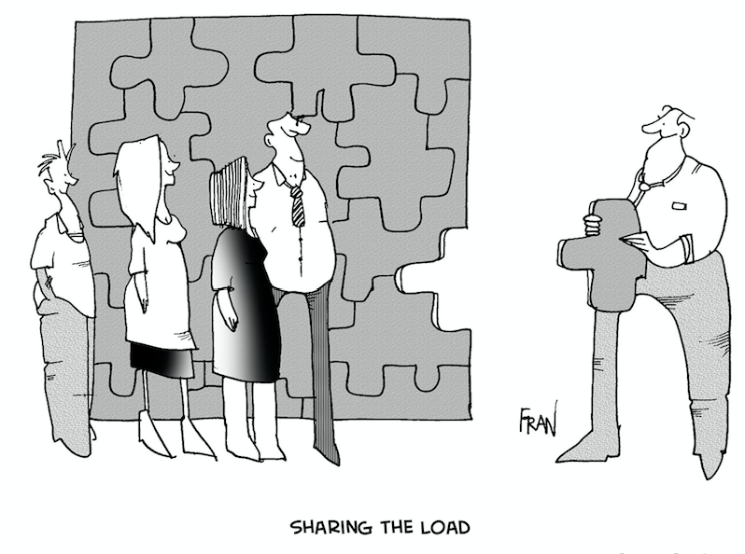
Team Theory
A team is a number of people with complementary skills who are committed to a common purpose, set of goals and approach for which they are accountable (DuBrin 2007). Team leadership is enabling the team to achieve the defined purpose.

Why Teams Work | Why Teams Don’t Work
Gathering of combined knowledge  Open communication  Sincere evaluation of delivery and outcomes resulting in reduced social loafing  Increased productivity in an atmosphere of cooperation  Potential improved job satisfaction  Skill development of the team | Using a team for something that must be done individually—e.g. creative writing  Calling a group a team but working with them as individuals  Not clarifying decision-making responsibilities  Not providing an organisational structure  Identified outcomes but inadequate resources for accomplishing them  Failing to skills-audit the team

Leadership Styles

Solo Leadership (Traditional)—basically autocratic and the single person receives much of the credit for success when frequently this singular credit is undeserved. The solo leader is often totally unaware of how dependant she/he is on the team.

- Plays unlimited role (interferes)
- Strives for conformity
- Collects accolades
- Directs subordinates
- Projects objectives

Team Leadership (Current)—willingness to surround themselves with capable people in order to multiply the effectiveness of the individual in a non-threatening atmosphere and an understanding of shared power.

- Chooses to limit role (delegates)
- Builds on diversity
- Seeks talent
- Develops colleagues
- Creates mission

Activities

Developing a Strategy Group Identity
- Individually list three adjectives that you feel best describe your strategy group (include one good and one bad) and identify why you feel that way.
- Share your descriptions with your strategy group and then discuss and identify an agreed Strategy Group Identity.
- Based on the agreed Strategy Group Identity, develop a motto or logo.

Role Clarification
- List what you see as your roles in the Strategy Group.
- Are they different from what you perceive that you do outside the Strategy Group?
- Share what you see as your roles in your group and discuss. Do others agree? Do you want to negotiate your roles?
- List what you need from the Strategy Group.
- Discuss what group members can do to help you achieve this.

Norm Setting
- List problem behaviour in a group that you have worked in before.
- Share this information in your group, with the group determining the importance of each.
- Take the 3 most important and develop Strategy Group ground rules using group processes.
- Write up the ground rules to achieve good behaviour. Focus on the positive rather than negative, be specific and unambiguous.
- Share your group’s rules with the other group and discuss.

Group Examples
Problem Behaviour | Ground Rules
Pursue private goals | Agree on and pursue common goals
Monopolise, dominate or withdraw | Share time and decisions
Ignore others or listen passively | Attend to others and listen to understand

Team Leadership

Essential Elements

- Foster Participative Leadership—Nurture empowerment
- Insist on Cooperative Climates—Encourage support
- Structure Decision-making and Problem-solving—Develop plans
- Leadership Action—Teams
- Define the team’s mission
- Develop the norm for teamwork
- Emphasise pride in being outstanding
- Hold whole group chats
- Model teamwork
- Use a servant leadership style
- Assist the team to establish timelines and direction
- Solicit whole team feedback
- Minimise micromanagement
- Emphasise group recognition and rewards
- Initiate group ritual and ceremony

One of the most important responsibilities of team leadership is to determine role designation. Rothwell 2004

Leadership
- Often there is an initial struggle for leadership—as if only one person does it in a group or team.
- Leadership can be to do whatever needs to be done to make a group effective—that is when anyone does something that improves productivity or satisfaction.
- Leadership is being aware of the process. This is the first step in taking responsibility for activities; i.e. reflecting on process and actions—why things work or not.
- Leadership helps others to achieve constructiveness.
- Leadership is being able to get the most out of a team or group.
- Leadership needs may change due to the stage a team is at.

W28—Media and Messages

Purpose
For participants to understand the process, complexities, challenges and rewards of working with the media.

Outcomes
Participants will:
Understand management of relationships with media people;
Understand the complexities of media releases, and;
Prepare and practise a media strategy for their projects

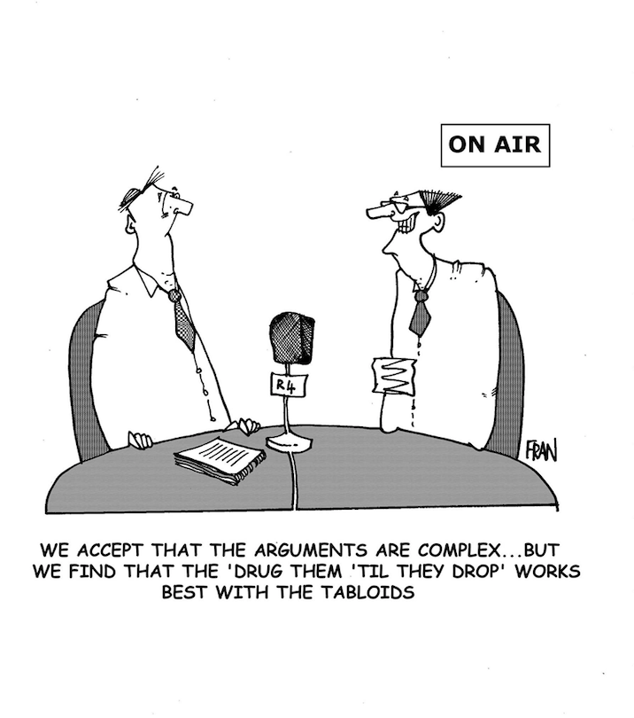

Media Strategy

Developing a media strategy depends upon the answers to several key questions:
- What is your goal?
- What is your organisation’s function? How well established is it?
- What do you want the media to tell the public about you and your organisation?
- Are you working with others or alone?
- What resources are available to you?
- Do you or people you know have media contacts?

Define Your Purpose/Message
- Get others involved. Form a committee/group of people to work with you to develop your media campaign. Be as inclusive as you can be, allowing people to contribute to the work.

- Determine your goals and objectives. Define your organisation and the goals you wish to achieve from the media message. Have a clear understanding of what you want to accomplish before you start.

- Create the message. Draft talking points that will answer basic questions about your issue. Make sure that everyone from your organisation is using these succinct and quotable talking points. You want one clear, direct, and simple message.

- Identify your target audience. Who is the audience you want to reach through the media? It is very important to know the intellectual level, social background and nature of the audience you are addressing.

Try to think like the audience you want to reach.

The media is the vehicle.

If possible, ask a member of your target audience or group to listen to you so you can test the message of your campaign.

Analyse and assess your media outlets and opportunities.

Which type of media will help you to reach your target audience?

List your resources.

These might include, but not be limited to the following: money, in-kind donations of material, the time and talents of involved individuals, outside or related events that you can use to highlight your efforts.

If possible, ask a member of your target audience or group to listen to you so you can test the message of your campaign.

Be clear about what you are trying to say, and what others think. Role play scenarios.

Remain flexible.

Revise your plans if circumstances or resources change, or if parts of your plan are not working. Stick with what works!

Basics of a Media Plan
Some basic points to address before you develop your media plan are:
- Learn about the media available in your city, state and country. Read the paper, watch TV, listen to the radio and follow other sources—blogs, email streams, bulletins, social media.
- Determine what will fall into hard news, or feature stories.
- Discover reporters who are covering issues similar to yours and whether they are reporting on them positively or negatively.

Press Releases

What is a press release?
A press release provides information about your organisation that is prepared and presented in a standardised format. It is usually one page in length, but no more than two pages. The purpose is to announce an issue of importance for which you want media attention, whether print, electronic or both. A press release should be brief and to the point.

What information should be included in a press release?
A good press release answers the "5 W's" in the first paragraph: i.e.
Who? What? Where? When? and Why?

Who: | Who is the subject of the story? They should be identified and described. The 'who' might be a person, group, event or activity.
What: | What is happening that the media should know about? The goal is to get the reader's attention, so that your release will be read and your issue reported.
Where: | If it is an event or a press conference, where is it going to take place? Be specific about the address of the location and include a map with directions. Include information about where to park a car or if there is public transportation. Make it as easy as possible for the reporters covering your event.
When: | When will it take place? The date, day of the week, and specific time must be very clear. No approximations; only specific information.
Why: | Why is this so important? The reason for your press release should be compelling. Be specific. Remember, the lead or headline should be written to hook the person into reading the rest of your release.
Social Media
In it’s most simple form the term social media refers to a computer-based technology that facilitates the sharing of ideas, thoughts, and information through virtual networks and communities. Social media is internet-based and gives users quick electronic communication of content, such as personal information, documents, videos, and photos.

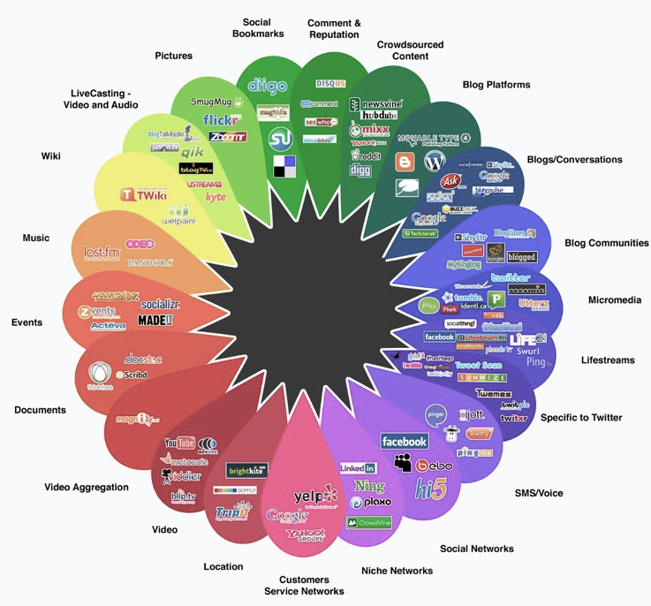

How social media has developed

A Simplistic Social Media Plan
- Who we will reach: Persona(s) most active/engaged on this channel

- Target goals/benefits: What this channel will accomplish; any unique opportunities that can’t be achieved elsewhere

- Featured topics: Subject areas/conversations likely to resonate with this community

- Ideal velocity: Frequency and post timing on this channel; how much time to spend monitoring and contributing to other relevant conversations

- Formats: Content types proven successful or emerging formats that might present a chance to own the conversation in that social space

- Tone and rules of engagement: Conversation style and voice; special criteria or considerations to follow (e.g., “280 characters or less,” “avoid enabling videos to play automatically,” “emphasize visuals over text”)

- Team resources: Role of person in charge of communication on this channel; other personnel authorized to post on company’s behalf; whom to notify if questions arise or issues escalate

- Call to action: Owned media/conversion point where to drive traffic

- Key performance indicators: Metrics to gauge content performance against goals

The Key – The Social Licence

The term social licence is the level of acceptance or approval that stakeholders and communities extend to a project, site, company or industry.

The topic of social licence has transformed over recent years from a metaphor for good community relations in the mining industry to a term widely used in many industries. The phrase ‘social licence to operate’ was coined in 1997 by a mining industry sustainable development executive called Jim Cooney, in discussions with the World Bank. He used the term as a metaphor to bring attention to the difference between a legal permit to mine and the social acceptance of a project.

The social license to operate is made up of three components: legitimacy, credibility, and trust.

- Legitimacy: this is the extent to which an individual or organisation plays by the ‘rules of the game’. That is, the norms of the community, be they legal, social, cultural, formal or informal in nature.

- Credibility: this is the individual or company’s capacity to provide true and clear information to the community and fulfil any commitments made.

- Trust: this is the willingness to be vulnerable to the actions of another. It is a very high quality of relationship and takes time and effort to create.

